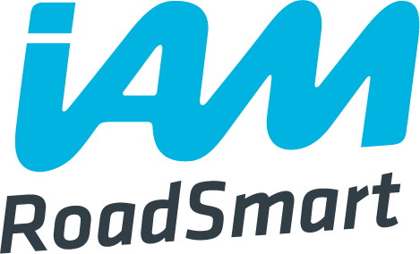
This precis is based on a draft document developed by IAM RoadSmart but as yet not published, it will in time link to the IAMRS data base, DARTS, and will allow a true Group Sign Off route for Associates who do not wish, for whatever reason to take an ARC examined test. As the full text is a draft CAM is not able to publish at this time. This precis is written to provide guidance on using a portfolio route to qualification. The final portfolio will be Quality Assured by CAM’s IMI liaison (currently Mark Tucker) and then forwarded to Shaun Cronin our ADSM for verification and final sign off and uploading to DARTS.
IAM RoadSmart - Membership by Portfolio
Course Outline
IAM RoadSmart has published the standards required for both Advanced Driving and Riding courses and for us at CAM these are contained in the Advanced Rider (ARC) Course logbooks. There is no reduction in the standards required for achieving membership by portfolio. This should never be seen as an alternative option for those to do not ride to the required IAM RoadSmart standards.

IAM RoadSmart training material and documentation is used throughout the course. The associate will be issued with IAM RoadSmart Rider Course Logbook and together with their nominated Observer be expected to develop a portfolio of qualifying evidence of competence using IAM RoadSmart run sheets. The accurate completion of run sheets is crucial in just the same way as it is for an Associate achieving membership by test.

In summary, there is absolutely no difference in the Advanced Rider course up to the point of conclusion, where instead of a test with an examiner, a portfolio of qualifying evidence will be submitted for consideration.

Membership Portfolio

A minimum of six observed runs with supporting IAM RoadSmart run sheets will be required to be in the portfolio before membership can be proposed. There may be more than six in the portfolio but six is the minimum number required.

The final two run sheets in the portfolio must have all the competency areas scored with a minimum score of 2 to indicate the achievement of the required Advanced standard. No area can be scored as a 3 or left blank. The approved run sheet is in the ARC Logbook and is shown in the appendix. The electronic version can be downloaded by Observers from the IAM website. Building an electronic portfolio of run sheets is recommended. Run sheets may be hand written within the ARC and submitted for approval. The Run sheet “observer’s comments” must corroborate the score awarded. Any score of 3 must have a development plan written for the candidate to work from.

Delivery Method
Observed runs may be undertaken by Local Observers and National Observers but the subsequent membership recommendation can only be delivered by a Local Observer Assessor. In CAM the Training Coordinator (Tim Collins) will assign an LOA to undertake a final check ride and sign off.

Portfolio Audit and Approval
Once the Associate has reached the required standard based on the opinion of the Observer, a group Local Observer Assessor will: -
Review the portfolio for evidence of development and competence and undertake a check ride
If the Local Observer Assessor is satisfied that the portfolio contains the required evidence of competence, the Local Observer Assessor will bundle the portfolio and check ride report and email to the IMI liaison (Mark Tucker) who following consideration with forward to Shaun Cronin ASDM for final verification and the final pass decision this will confirm the required standard has been achieved, confirm membership and activate the issue of a membership certificate.

Membership Status
Once confirmed by the Regional Service Delivery Manager the Associate will achieve full member status. A pass or F1rst award can be made with supporting evidence. There will be no difference in membership status by taking the portfolio option. The member is entitled to the full range of benefits that IAM RoadSmart offers.
The member can become an Observer. There is no change in the process required to achieve IMI Local Observer or IMI National Observer status.

Group sign off precis V2
Mark Tucker
06 12 2021

