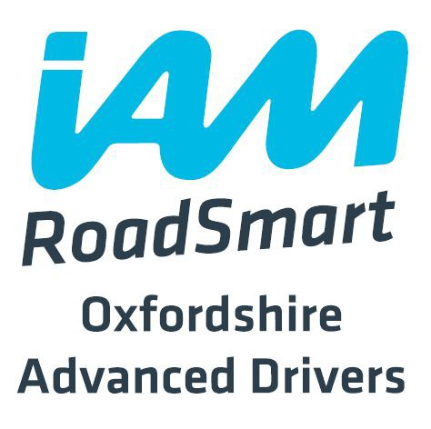

Registered Charity Number 1080450

GIFT AID DECLARATION

Details of Donor :

Title .…. Forename(s) ………………………………………… Surname: ……………………….…. Address …………………………………………………………………………………………………
……..………………………………………………………………………………………….. Postcode …………………..

Declaration :

I wish Oxfordshire Advanced Drivers to treat all donations that I have made since 6 April 2000, and all donations I make from the date of this declaration, until I notify you otherwise, as Gift Aid donations.
I confirm that I pay income tax and/or capital gains tax at least equal to that the charity reclaims.

Signed : …………………………………………………… Date : …………………………………….

Notes:

- You can cancel this declaration at any time by notifying the Group Treasurer

- You must pay an amount of income tax and/or capital gains tax at least equal to the amount of the reclaim on your donations in the tax year

- If in the future, your circumstances change and you no longer pay income tax and/or capital gains tax equal to the amount of the reclaim, you must notify the Group Treasurer

- If you pay tax at the higher rate you can claim further tax relief on your Self Assessment tax return

