

**How to write a press release**

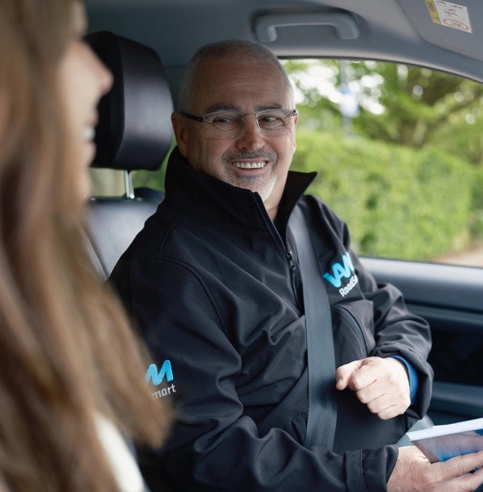

**Guide and template for IAM RoadSmart fundraisers**

**1 - What is a press release?**

A press release is written to help a journalist quickly understand a piece of news about an organisation – such as a fundraising event. It should be concise, factual, and structured to capture the attention of journalists and news outlets.

**Key Elements of a Press Release**

* Headline – Clear, catchy, and summarises the news
* Sub-heading – Adds a bit more detail or intrigue
* Lead Paragraph – The “5 Ws”: Who, What, When, Where, Why. Some journalists won’t read further than this, so it's important to keep this short.
* Body Paragraphs – Additional context, background, and details.
* Boilerplate – A short paragraph about the company or organisation.
* Press Contact Info – Name, email, phone number.

**Is it news?**

Just because something has happened doesn’t always mean it’s news, or that it’s newsworthy. It is critical to start any press release by thinking of your audience (both the journalist and their audience). One way of determining whether something is newsworthy is to use the TRUTH acronym, which covers the five common elements of news. It’s broken down into:

* **T**opicality / timeliness (has it happened or will it happen soon?)
* **R**elevance to the target media and to their audience (is this something they typically cover?)
* how **U**nusual or unique this is
* **T**rouble (for someone) – or is there tragedy or triumph over tragedy (all of which create tension and emotive hook)
* **H**uman interest (are the audience involved or affected by this story?)

Ideally, your press release should always be topical, relevant and include one of the other three elements of news – or, in an ideal world, all of them!

**Pitching a press release**

Know the media you’re sending your release to. Even better, know the journalist, the stories they typically run and the topics they cover. Stories about a fundraising campaign will be best sent to your local newspaper or radio station. For newspapers, find out whether they are a daily or a weekly, ensuring that you give journalists adequate notice to write up your press release. It can be worth calling the news desk to make sure your press release has been received, as journalists receive hundreds – but be prepared to talk through what your press release is about.

**Photos**

Print / digital journalists will usually want images to go with their story. Make sure you have something to offer them, either by attaching a selection to the email, or by offering a photo / filming opportunity. If attaching files to the email, ensure these are low-res so as not to fill up journalists’ inbox, but keep a high-res file available for print.

**2 - Writing the press release**

**Start with the headline**

Make it short, clear, and attention-grabbing. Try to make the headline show why the story matters to the journalist. For instance, if you are pitching to your local newspaper, location is key – “Guildford bus driver scales Everest to raise money for road safety charity”. Human interest also works well and makes a story more relatable to readers, for example “Guildford mum raises money for road safety charity after teenage son dies in crash”.

**First paragraph:**

This should build on the headline and encourage the reader to continue. Keep it very brief—ideally one sentence of no more than 20 words (definitely under 30). Focus on the basics: who, what, when, and where (especially for local media). Look at how local and national newspapers—especially tabloids—write quick, punchy intros.

**Second to fourth paragraphs:**

These should go deeper into the story. Explain why it happened, how it came about, and why it matters to the reader. Answer the question: “What does this mean?”

**Include a quote (optional):**

Quotes aren’t always necessary, but they can add personality and insight. Study how newspapers write quotes and aim to match their tone. Avoid empty phrases like “strategic partnerships” or “innovative occurrences,” and stay away from vague terms like “pleased”, “thrilled” and “delighted”. Quotes between 60–100 words are fine, but be aware journalists may cut them down and are often looking for soundbites. A good soundbite often gets used in a headline.

For example:

Quote: IAM RoadSmart spokesperson said: “These figures show we’re losing the toxic battle against drug driving”

Headline: “Toxic”. How Britain’s drug driving habit is destroying lives”

Finish with ‘ENDS’ to mark the end of the press release.

**10 lessons from George Orwell**

The famed writer and journalist George Orwell was passionate about clear, direct writing. His ‘elementary rules’ are still used by many journalists to develop a good, plain style – decades after they were first published. They’re worth remembering –not just for press releases, but all types of copy:

* Never use a metaphor, simile or other figure of speech which you are used to

seeing in print (avoid clichés).

* Never use a long word when a short word will do (don’t be pretentious).
* If it is possible to cut out a word, a sentence or a paragraph, always do so

(edit, edit, edit).

* Always use the active voice, not the passive. (e.g. passive – the car was driven by Jim; active – Jim drove the car).
* Never use jargon, a scientific word or a foreign phrase if there is a straightforward English equivalent.

**3 - Press release template**

**PRESS RELEASE**

**IAM RoadSmart**

**For immediate release**

**<** **INSERT TOWN> resident <insert fundraising activity> to raise money for road safety charity**

*[If applicable insert details here for photo opportunity AND/OR send your photos]*

*Photo opportunity: [Insert what the photo opportunity is here e.g. Local woman rides for 48 hours on a static trainer in gym to raise money for road safety charity.*

*Time/date: [Insert time when event is taking place]*

*Contact: [insert contact details to arrange photo opportunity]*

Local resident [Insert Name] from [Insert Location] is set to [Insert Activity e.g. run/trek/swim/cycle/host a show] on [Insert Date] in support of road safety charity IAM RoadSmart.

*Insert some background info about yourself in the paragraph below, and more information about what you’re doing and where. You could include information about your job, your age, your motives for doing your fundraising activity, why road safety is important to you.*

[Insert Name] said: “[Insert personal quote – talk about why you chose this activity, what it means to you, how you’re preparing, why supporting IAM RoadSmart matters, etc.]”

*Add anything else that is relevant about your campaign here.*

*Insert a quote from a relevant person, such as an Observer in your Group:*

<Insert name>, Chief Observer for <insert name> Advanced Motorists/Motorcyclists/Drivers, said: “We are really grateful to <insert name> for choosing to support IAM RoadSmart through <challenge/event>.

“Every day five people lose their lives and 80 are seriously injured on the UK’s roads. We believe that every journey should end with a safe arrival – not a tragedy. Campaigning for road safety in the UK isn’t just about rules and regulations; it’s about protecting lives, families, and futures. One moment of awareness can save a lifetime of regret.”

To support [insert name] and [insert action e.g. donate/sign-up/take part] please visit [insert weblink for fundraising page].

ENDS

**Notes to editors**

This press release has been generated and sent by a fundraiser and not by the IAM RoadSmart media team. For more information, please contact [insert name] on [insert your contact name, telephone number and e-mail address.]

**About IAM RoadSmart**

IAM RoadSmart is the UK’s largest road safety charity providing advanced driver and rider training. It has a vision of a society where all road users can safely use the public highways together.

IAM RoadSmart was formed in March 1956 and has around 70,000 members and 5,000 volunteers that support its campaigns on road safety. At any one time there are more than 7,000 drivers and riders actively engaged with IAM RoadSmart’s courses.

The charity also delivers courses in the workplace. To find out more about how IAM RoadSmart can help with fleet and work training visit [www.iamcommercial.co.uk](http://www.iamcommercial.co.uk)

To find out more about IAM RoadSmart go to: [www.iamroadsmart.com](http://www.iamroadsmart.com)

**Follow us:**

Facebook: [www.facebook.com/IAMRoadSmart](http://www.facebook.com/IAMRoadSmart)

X (formerly Twitter): @IAMRoadSmart

Media centre: <https://media.iamroadsmart.com/>



Call **020 8996 9777**

Email **press.office@iam.org.uk**